**Time Complexity**

**Running time analysis:** Basically, determines the processing time of problem with respect to the input size (number of elements). Example- Size of array, polynomial degree, vertices and edges in a graph, etc.

**Comparing of algorithms**: Are dependent on the times operations are performed on input values. Like addition, subtraction, division, modulo, etc.

We consider the highest complexity and leaves the rest in approximation. Example, if the complexity is n2 + 2n + n4 , then we’ll consider the complexity to be n4 .

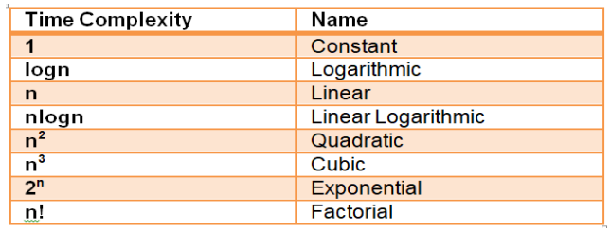

**Types of analysis:**

1. **Worst-case analysis:** It consists of the inputs which takes longest time to execute. Asymptotic notation is Big-O.
2. **Best-case analysis:** It consists of inputs which takes the shortest time.
3. **Average-case analysis:** It consists of inputs which takes average running time.

**Space Complexity**

The amount of space in the memory occupied by the input size is determined by space complexity.

**Auxiliary space:** the extra space used by an algorithm to solve a problem.

**Space Complexity:** It is the total space used by an algorithm to solve a problem. Space Complexity = Auxiliary space + space taken by input size